How to register for the TMOA association through Arbiter
www.tulsametroofficials.com
You will have to register each season through Arbiter and pay the $30 TMOA Association Fee to receive games from the TMOA & Johnny Johnson starting with the 2022-2023 school year. There will be no exceptions – we are here to help you get registered.
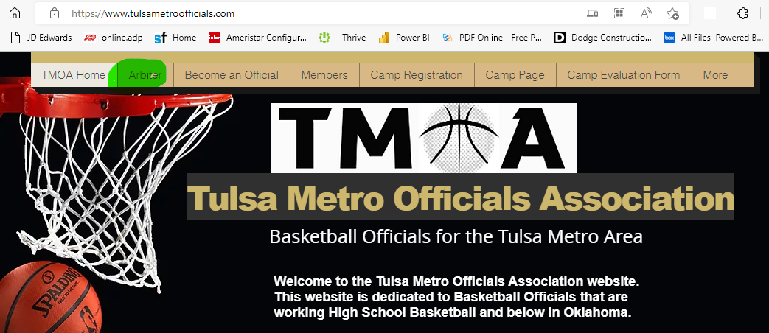
Or down a little further on the home page you can see the big RED button
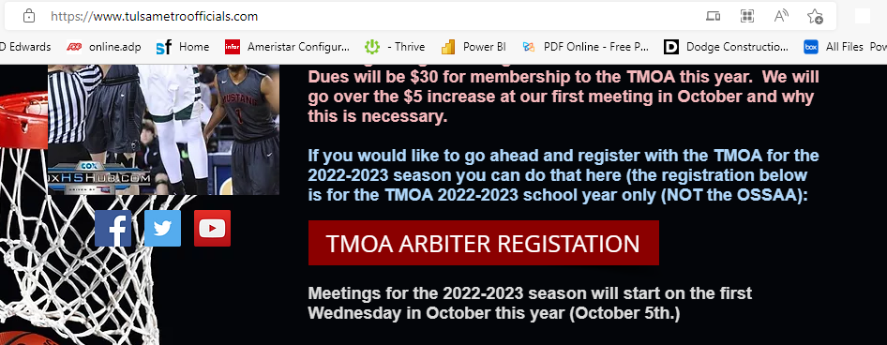
When you select either of these, this window should pop up
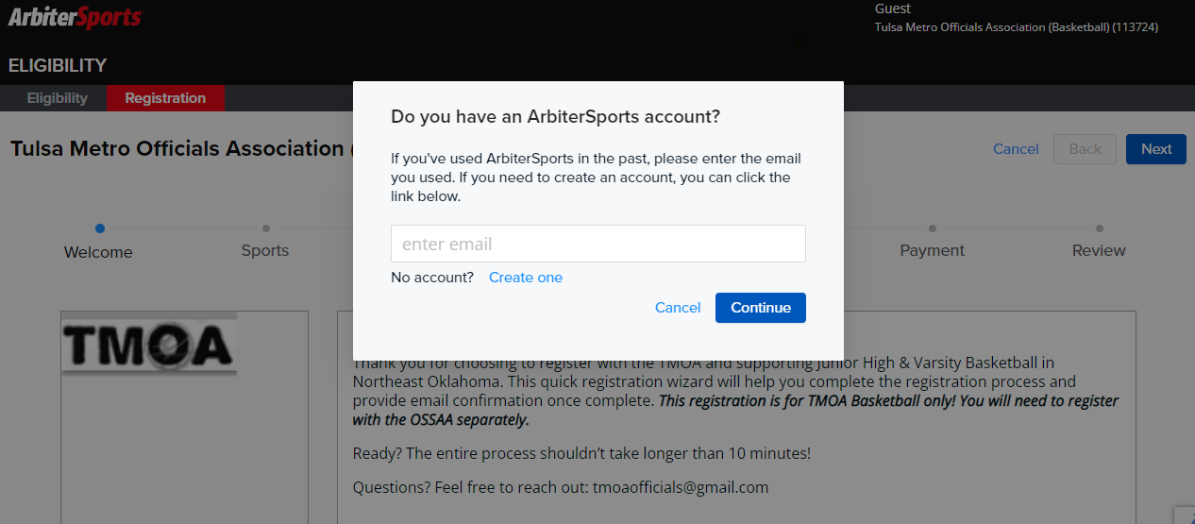
If you are brand new select the Create One option above

Enter your email if you have ever registered on Arbiter (if you have registered with the OSSAA you already have an Arbiter login)
Then it will ask for your password (if you don’t know it use the forgot password) TMOA does not have nor can we see what your password is.

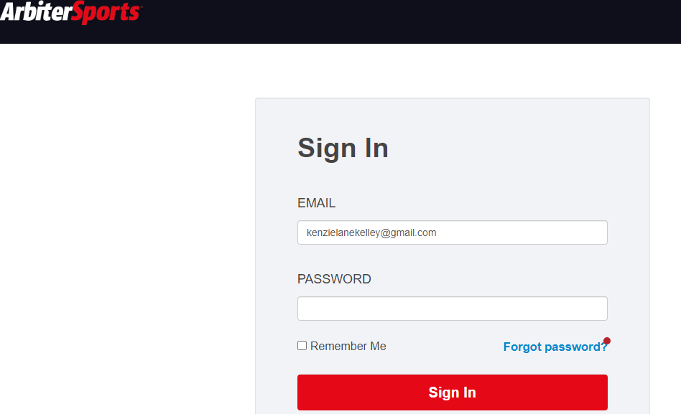

Once you are logged in it should go to this screen – but if not, go back in the same browser and select the big red Arbiter Registration button on the TMOA home page or the Tab that says Arbiter.
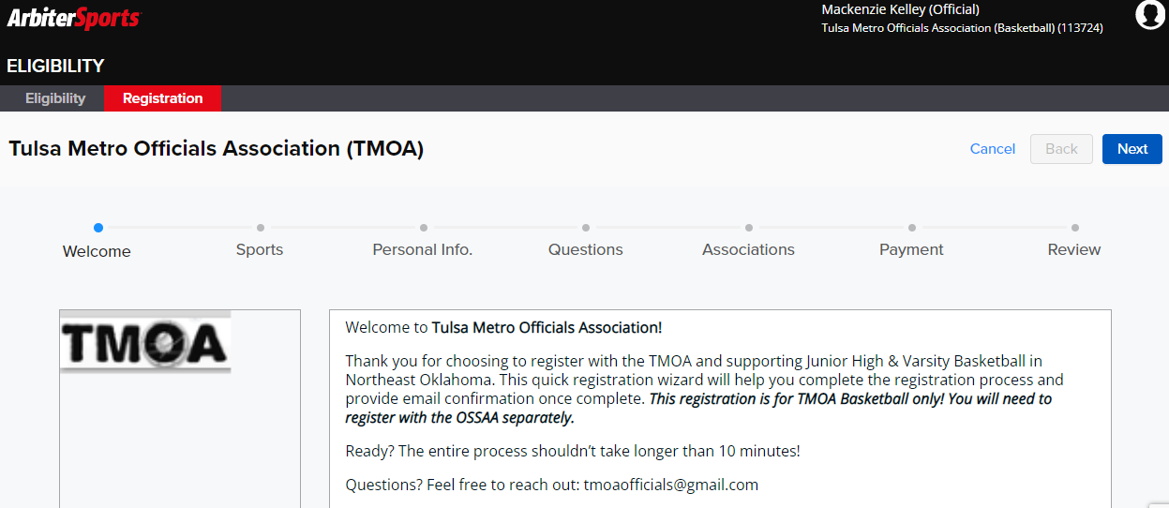
Select the Next button in the top right corner of the screen
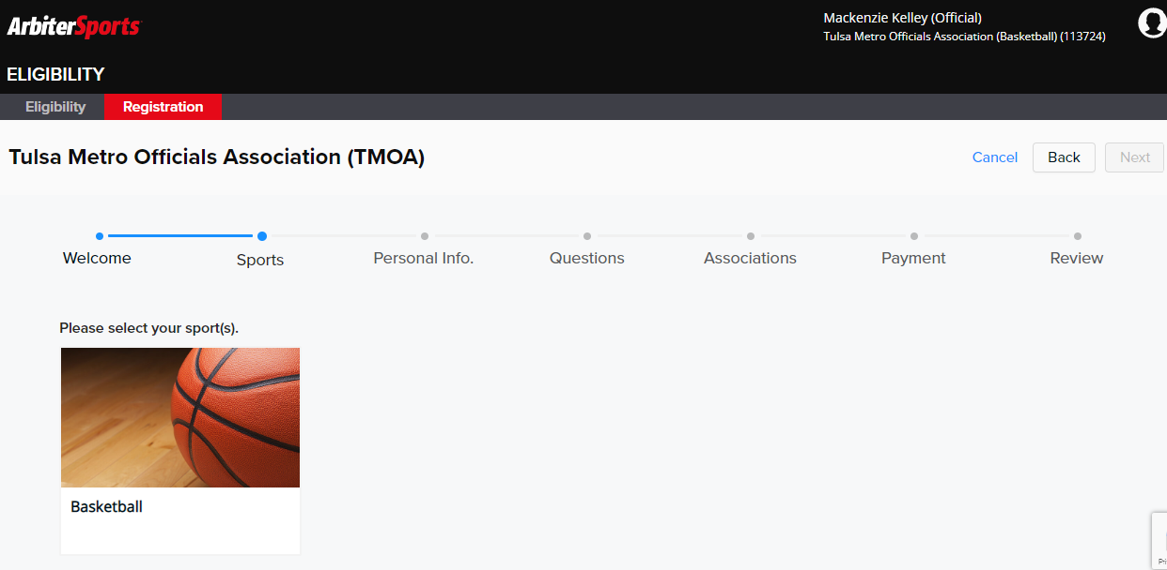
Then select Basketball (run your mouse over the basketball and then you can select it)
If you have never registered, then you will have to fill this info out. If you logged in earlier, it should be populated. Select Next if it is good or make change as necessary and then select Next. PLEASE ADD A PHOTO (there are 150+ officials, put your face with a name)
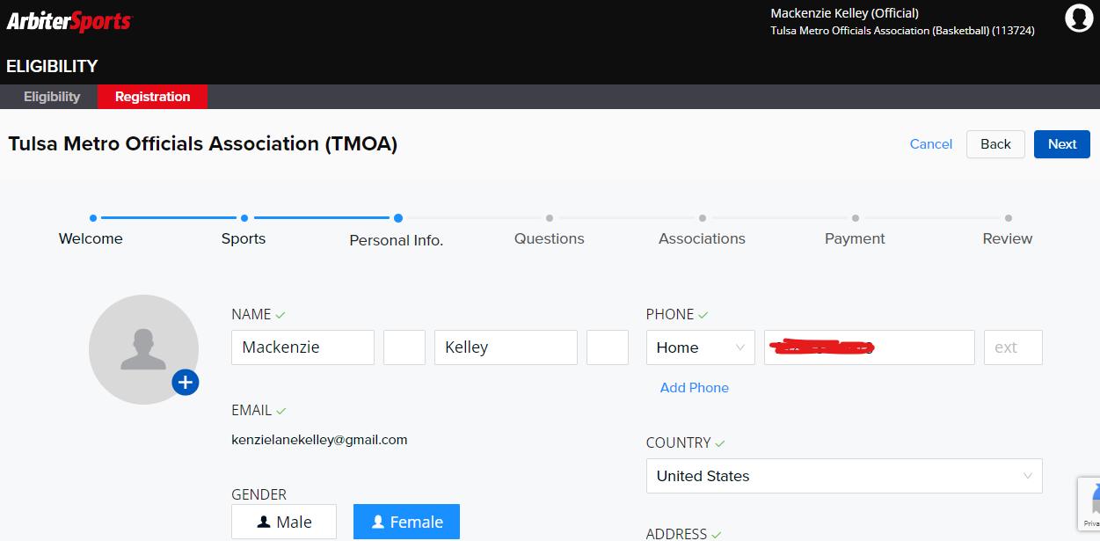

Then you have to answer these 2 questions (you have to select YES on the independent contractor question) and then your shirt size (no guarantee you are getting a shirt but IF you were to, add your size)
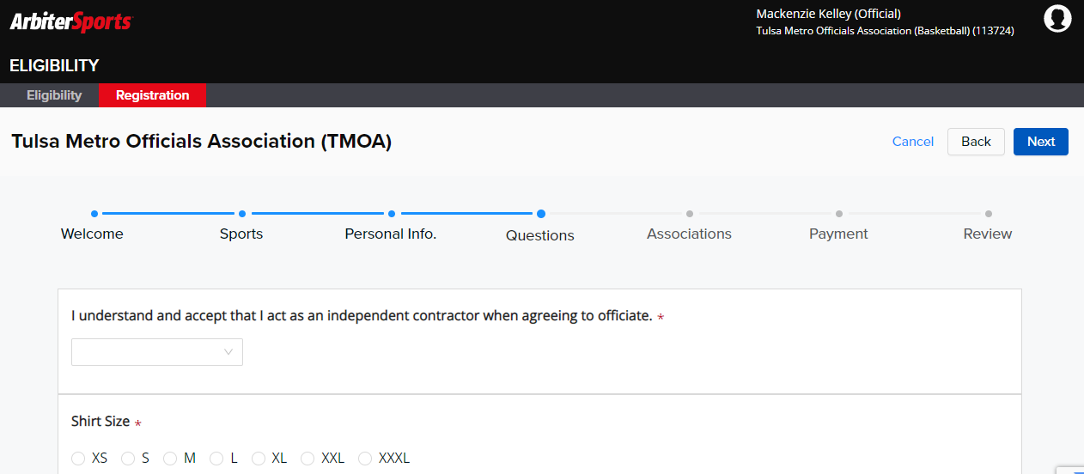
Breeze on through the next screen – nothing to add on this one. This one would be used if you were registering for multiple sports. We are Basketball Only
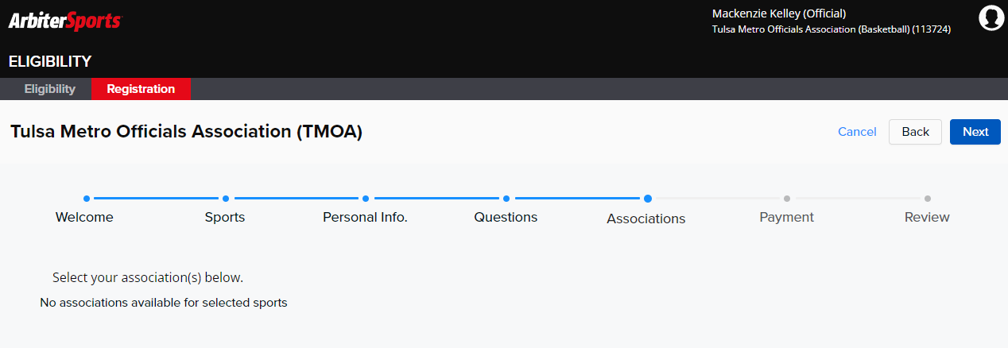

Next is payment – make sure everything looks good on this one and then at the bottom select Check Out (Blue botton)
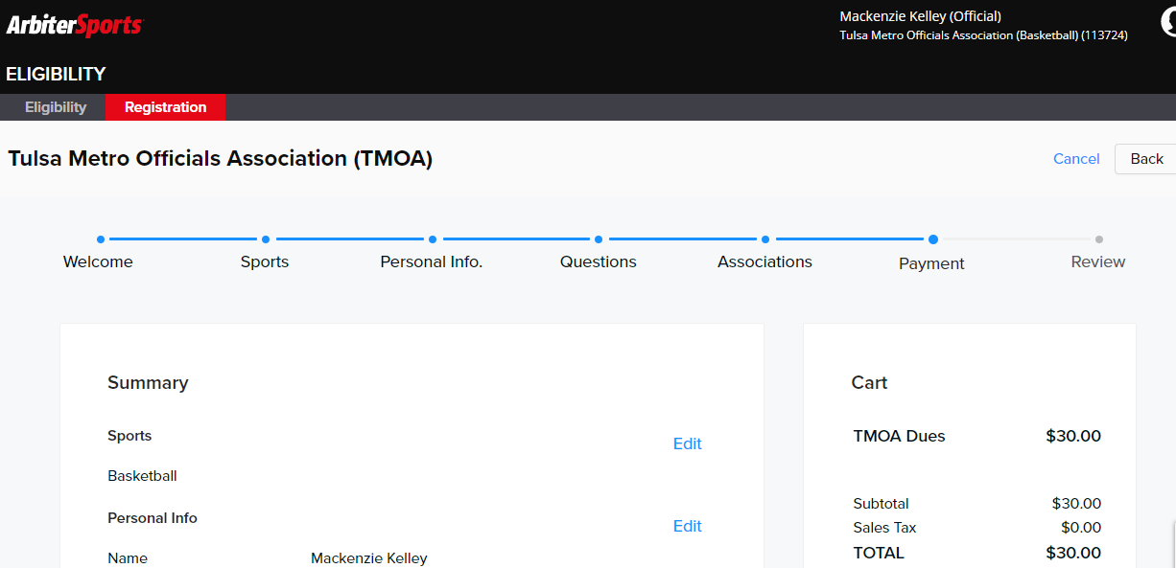

Make sure your address is correct and then go to the bottom and select NEXT again
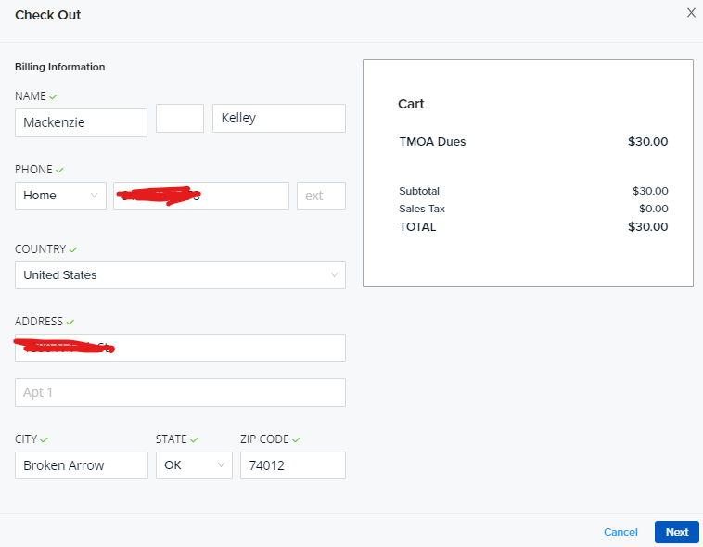
Finally, you will be to the process payment page where you will add your debit/credit card information. Verify your bank card information and select the box that says you agree to the terms of service and then select Process Payment
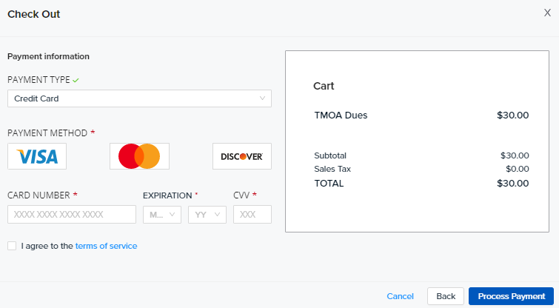
If payment is successful, you will get this next screen along with an email
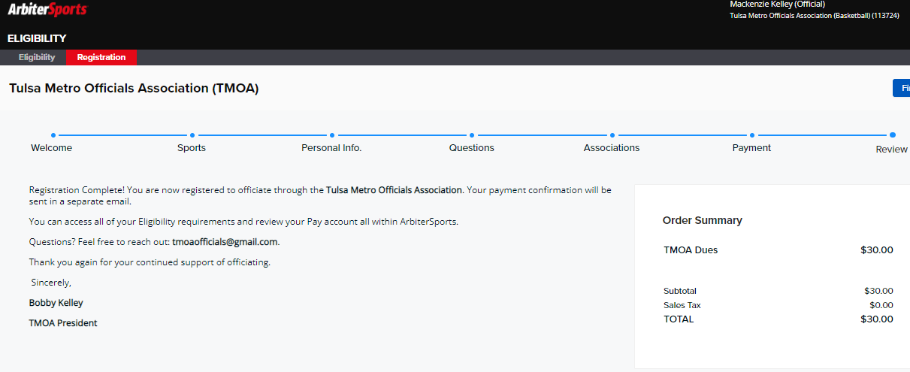

And here is the email confirmation:
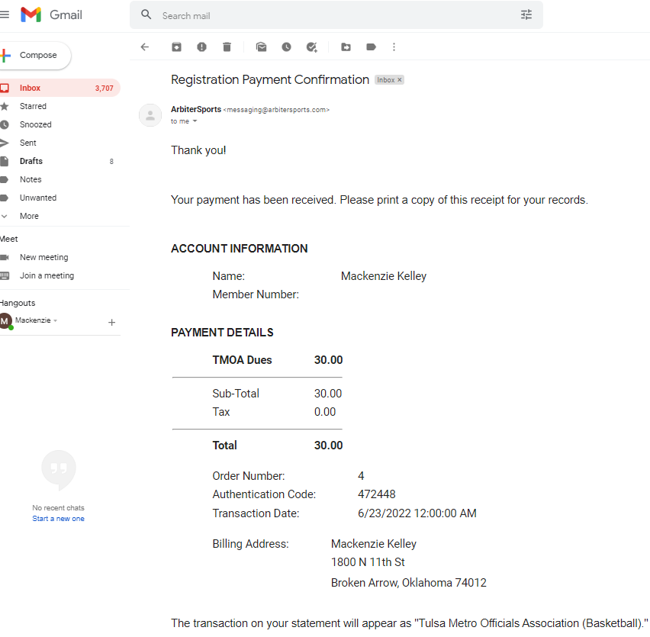

Once you select Finish it should go back to this screen and you can see the green checkbox on here that shows you are registered successfully
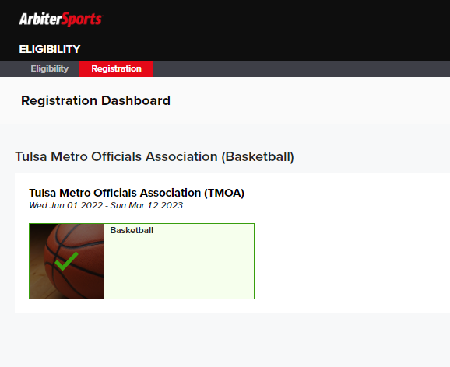

Go to the top right and select the down arrow next to your name and this will pop up:
Then select the blue Official to go to your dashboard
And it should look something like this:
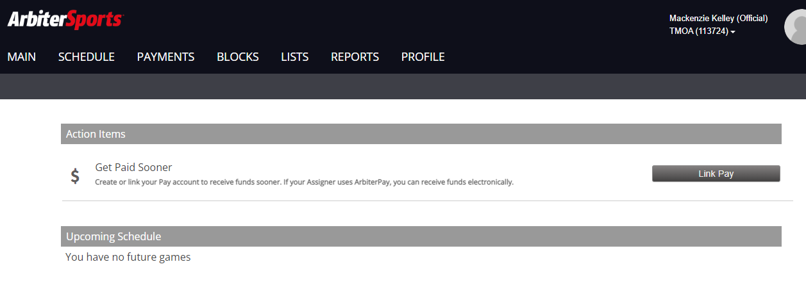

Select Main and you can put Basketball at your Default Generic Sport
And Select Basketball again under Sports Levels currently.
Check mark the boxes under the generic level that you call and then the Add Button
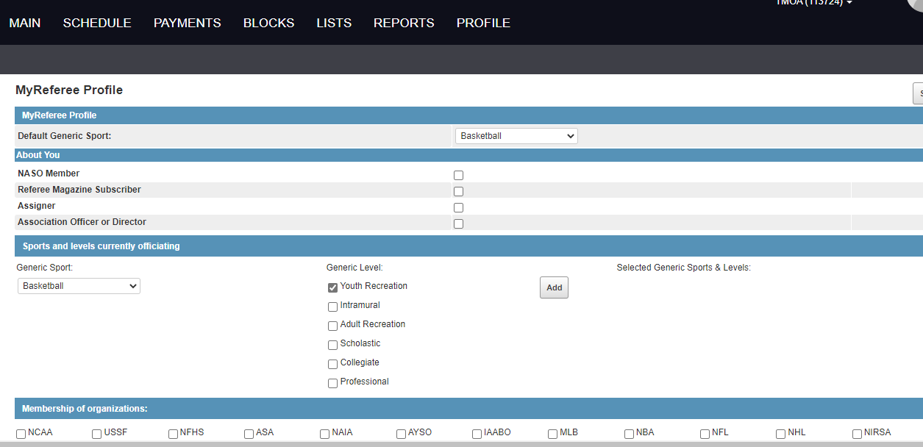

Under Schedule this is where you will see your games and accept them:
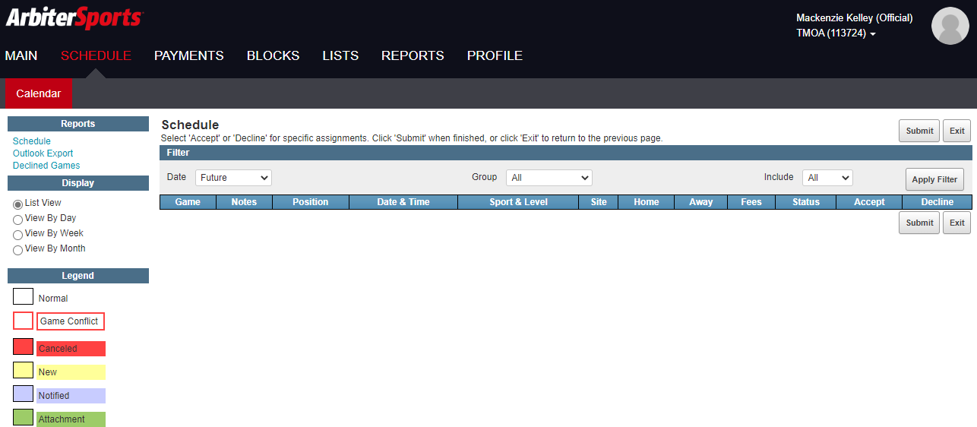

Under payments – we would recommend you link an account if you don’t already have one for OSSAA playoffs – schools are able to use this option to pay you although right now we don’t believe there will be many that do this.

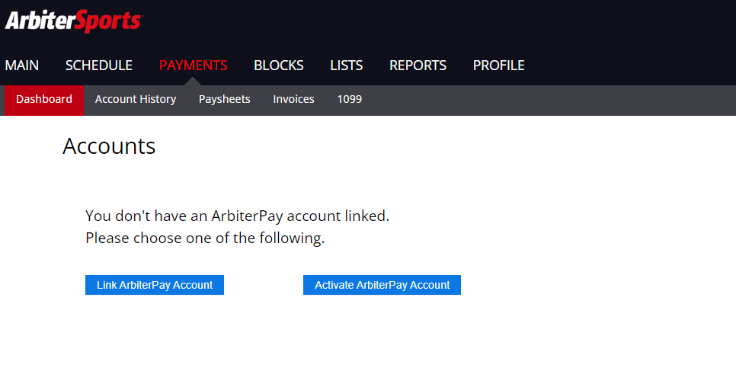

Under the BLOCKS tab is where you will keep your availability up to date. You can also scratch sites/teams/partners/postal codes (but be careful on how much you scratch as it could limit how many games we can assign you) you will need to keep your availability up to date and go in an block dates when you cannot work. If you receive a game from elsewhere, you will need to go block that date/time on here. This will be important!
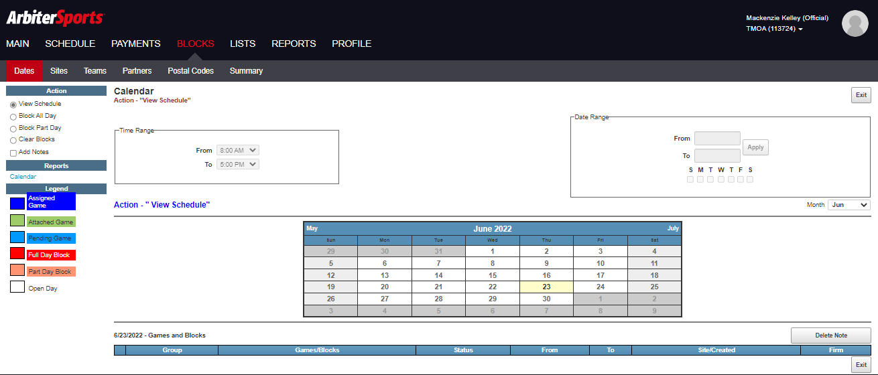

Under the LISTS tab you will be able to see officials contact info, Assigners, officers, School contacts and Sites:
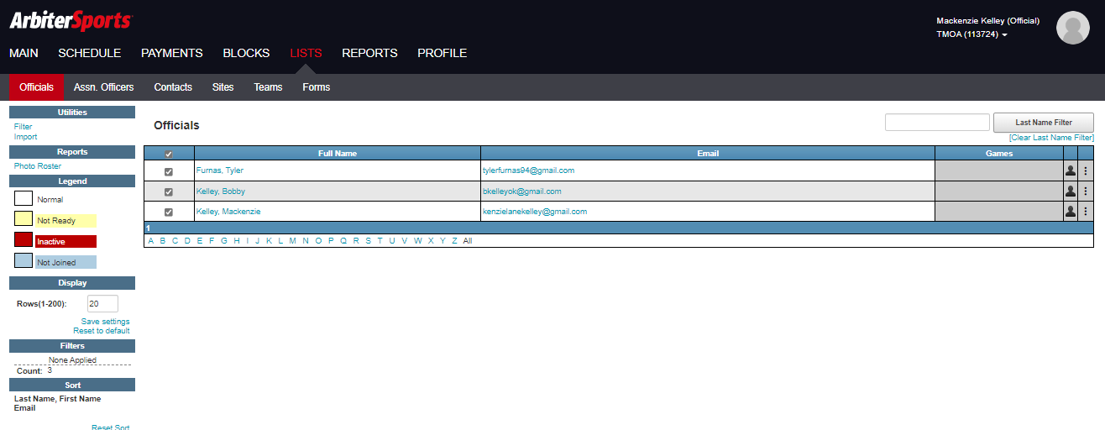

If you have any questions with Arbiter, please contact Bobby Kelley for help. We will go over using this system during a couple of our meetings in October.

